## 

Bachelor of Computing with Honours in Internet Technology

FINAL YEAR PROJECT

Interim Report

Topic: An Intelligent Index Tracking System

Fyp_fyp

|  |  |
| --- | --- |
| Student Name | Student ID |
| FUNG Wai Yin | 11965651 |
| PUN Cheuk Kwan | 12213395 |
| YUNG Chun To Samuel | 12108522 |

Supervised by

Dr. LEUNG Man Fai

## **Table of Contents**

**Table of Contents** **2**

Declaration Page **4**

Preamble **5**

Chapter 1. Introduction **5**

A. Overview 5

B. Project Aim 5

C. Project Objectives 6

D.Updates to the Aim and Objectives 6

E. Value Propositions 6

**Section 2. Background or Literature Review** **7**

A. Problem Analysis 7

B. Related Technologies 8

C. Review of Existing or Related Solutions 8

**Section 3. Preliminary Methodology** **9**

A. Overview of Methodologies 9

B. Requirements and Key Technologies 10

C. Design of the Solution 10

D.Detailed Design of Selected Components 11

E.Implementation Issues of Prototype 11

F.Evaluation Design 11

**References** **12**

Appendix A. Progress Report **13**

Overview of Project Progress 13

Revised Project Plan 13

Appendix B. Team Members' Roles and Responsibility **14**

Appendix C. Team Meeting Minutes **16**

**Appendix D1. Fung Wai Yin's Interim Report** **17**

A. Information Box 17

B. Declaration Statement 17

C. Tasks Assigned to the Author and their Status 17

D. Key Successes and Failures by the Author 18

**Appendix D2. Pun Cheuk Kwan's Interim Report** **19**

A. Information Box 19

B. Declaration Statement 19

C. Tasks Assigned to the Author and their Status 19

D. Key Successes and Failures by the Author 19

**Appendix D3. YUNG Chun To Samuel's Interim Report** **20**

A. Information Box 20

B. Declaration Statement 20

C. Tasks Assigned to the Author and their Status 20

D. Key Successes and Failures by the Author 21

## Declaration Page

We,

**FUNG Wai Yin(11965651),  
PUN Cheuk Kwan(12213395),  
YUNG Chun To Samuel(12108522),**  
Certify that the work is original and we have utilized guidance of our supervisor in completing this project, and that the content which is not our own has been attributed and referenced properly. There should be no copyrighted content without permission to use. There should be no confidential data.  
We declare that the description and information outlined in the individual team member reports are true reflection of the project status to the best of our knowledge.

Signature and Date

|  |  |  |
| --- | --- | --- |
| ___________________________ | FUNG Wai Yin(11965651) | 04/02/2020 |
| ___________________________ | PUN Cheuk Kwan(12213395) | 04/02/2020 |
| ___________________________ | YUNG Chun To Samuel(12108522) | 04/02/2020 |

## 

## Preamble

This project titled “An Intelligent Index Tracking System” started on 1-9-2019 under the supervision of Dr. LEUNG Man Fai. The project was initiated due to an observation on inconvenient and unfriendly caused by the current index tracking system, and the difficulty for the newcomers to learn to invest in the stock market.

This report is written to describe the project objectives and their progress, and to provide a conceptual framework for the solution in the project.

## Chapter 1. Introduction

### A. Overview

Financial services, one of the most important sectors for Hong Kong to earn their income, at the same time, many Hong Kong citizens also make their alternative income through the stock market, which build a very active stock trading activities and vibrant banking activities. (Census and Statistics Department, Hong Kong Special Administrative Region, May 2019)

Nowadays, there are many ways to invest related to index such as Exchange Traded Funds (ETF). ETF is one of the most well-known investment methods, this fund is using index tracking to make profits from the market by average investment profits. An ETF is a fund without an agent's judgment but traded by fixed index. The purpose of an ETF is using the lowest cost to track the overall market return.

However, we found out that the ETF is unfriendly to newcomers who want to start investing, as there are too many stocks among the world. The most common way to evaluate the performance of stocks in each industry or region is that, the number of representative companies will be extracted to be a fractional stock.

### 

### B. Project Aim

The project aims at providing a convenient trading system for newcomers to learn quickly and use a lower cost to earn the profit from index. To start with, the current situation in the stock market will be introduced. As mentioned above, to evaluate the performance of stocks, fractional stock is chosen, they form the index to show an overview of performance. In the market, some indexes are famous such as Hang Seng Index(HSI), Standard & Poor’s 500, they use at least 500 fractional stocks to calculate the index.

It causes a problem that, for the newcomers, it is difficult for them to understand the operation of the stock market, as there are too many fractional stocks to look at. Some newcomers may seek help from trading agents, who are in charge of managing the stocks for their customers and provide suitable advice by their analysis on the market. However, most of the agents charge for the wage by each transaction, which leads to another problem, the cost will be extremely high if the client chooses to invest in multiple markets at the same time, if newcomers want to learn quick in the stock market by understanding numerous market, it is extremely difficult for them to invest in the market.

### C. Project Objectives

The proposed objectives are:

* Collect data from the stock markets
* Data Analysis to help investors
* Design and develop an integrated platform for investors
* Evaluate new application against current method

### D.Updates to the Aim and Objectives

After the discussion of group mates, we are going to decide to add a aim to gain profit from the index by predicting the index.

### E. Value Propositions

The newcomers, investors, who are struggling to invest in the market, or have difficulties in focusing multiple stock market, are our potential users. We provide a web-based application which is composed of a data analysis system and an integrated platform. The newcomers can enter the stock market at a lower difficulty and familmize with the stock market. It can shorten the time for them to explore in this sector. As for the investors who have invested in multiple stock markets in different regions, they can make good use to manage their stock with the data recorded by the system, which can help them investing in the market well.

Besides data analysis from the stock market, the system may provide financial news analysis, which is depending on the news from financial markets, prediction may be made by the system, and provide suggestions to investors. It can help the newcomers and investors to predict the flow of the stock, which may be different by just comparing the data in the market. It can increase the accuracy of the prediction of the stock market.

## Section 2. Background or Literature Review

### A. Problem Analysis

For the newcomers, they want to participate in the stock market by using an ETF, but there are two problems with using an ETF. It is an investing index by fund managers that need high cost and it is difficult to let newcomers learn investment.

Due to the cost of ETF, the cost is including handling fee, transaction tax, fund manager fees, custodial fees, index authorization fee, listing fee and the cost of adjusting the investment.[[2]](https://djinfo.cathaysec.com.tw/school/ET920000.htm) Also, some of the ETF is include a lot of fractional stock, some of those fees are charged by each stock trading. In addition, ETF investment mostly uses traditional indexing to index tracking, it means the fund is including all the fractional stock of the index. Investors need to have a large principle to invest in all fractional stocks. Otherwise, the index performance cannot fully represent the profits of the ETF. For being high accuracy, the cost will also become higher. Therefore, the newcomers find it difficult to afford such high cost for investment.

In addition, for those investors who do not want to spend time managing their investment ETF may be a good choice for them to get in the investment market. However, some of the investors want to learn how to invest in stocks by themselves through index tracking. In this situation, an ETF is not suitable for them, because they cannot learn anything by using a fund manager.

### 

### B. Related Technologies

After the research, there is no software that is exactly index tracking software provided for the newcomers. Even a normal index tracking software, it does not provide for the public to download. The main reason for no exact index tracking software is that most of the investors were invested through fund managers rather than themselves. Since the fund manager will be more convenient and save time. However, it is unable to let newcomers learn any investment knowledge from investing index.

Some of the similar software was found is portfolio tracking[[3]](https://programmingforfinance.com/2018/02/tracking-a-portfolio-with-python/), it is tracking the stock portfolio. The function of this software is input the self-chosen stock portfolio, the software will be tracking the performance of the stocks on daily or the past. Also, the software will rebalance the rate of the stock invested to make average invest profits, the daily report also will generate automatically to report the return and performance of the stocks. In addition, it can generate the chart to display the risk and return of the stocks. Most data of this software comes from an API call ‘Quandl’, this API will provide the stock symbols, the historical data benchmark symbol and set the data starting date.Yahoo finance also provide much data to calculate the index.[[4]](https://finance.yahoo.com/) Due to the rebalance function, the rate of the stocks is set by user, but the rate may not be the most effective to get the profits. Also, the function of rebalance is only reset the rate to become the original rate which is set by the user. Therefore, by using AI, it can calculate the most effective rate for the stock to get more profits. Also, the software only displays the proportion of the risk and return of the stock. It does not have a risk assessment to the user to find out how high risk the user can be afforded. So that, the software should provide a risk assessment to the user to let them know about the risk level they can afford.

### C. Review of Existing or Related Solutions

For the previous system, it has some suitable for us to be the reference. The API ‘Quandl’ is a good resource to get the historical data for free, it provides the current price, opening price, closing price of the stock between the period. It also provides a different type of chart for us to build for the user to easily compare the return and risk.Such as Correlation Heatmap, Violin Chart and Risk-Return Plot etc. But there is something that can be improved, the ‘Quandl’ API has stopped updating. Therefore, we need to find a new API to get the data.

The previous are not suitable for our purpose and there is some function that can be improving, so that we must develop a new system which targets the index. Make the difference between the original index and the virtual index of our system to be minimized. At the same time, the user can be the lowest cost to track the overall market return, thus increasing user passives incomes.

## Section 3. Preliminary Methodology

### A. Overview of Methodologies

In this final year project, we are going to make a system which can help newcomers or beginners assimilate into the financial market. Users can use less time to learn about the market. Traditionally, if people want to be a stock investor, they always need to pay amounts of “tuition fee”. They need to learn from failure, which means losing money. Using our system, they can easily monitor the stock and the news about those stocks. The system will send a message to notify users if a news mentions it. Since the new will affect the index, users have to change the investment plan manually. Those new factors are not included in the prediction.

Also, our system has an index tracking function. Users can easily get all the data they need to analyze the market trend.The main difference with other similar index is that our index is going to have less constituent companies to represent the market performance. That means users can get almost the same effect by using less trading fee.

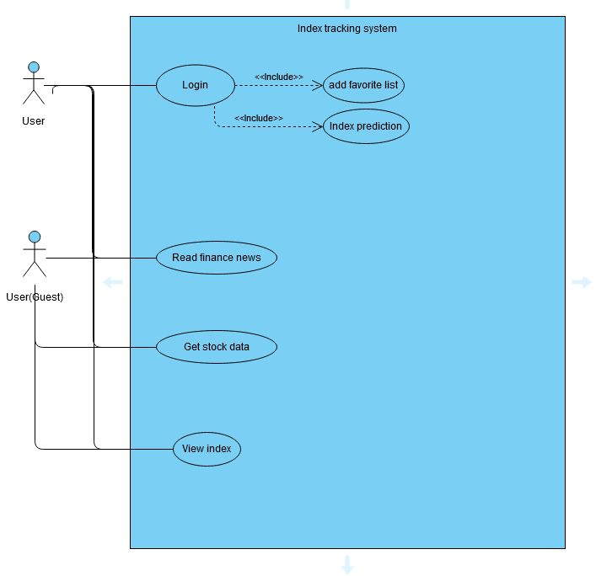

### B. Requirements and Key Technologies

The functional requirement as below:

* Index tracking closely with original index
* Similar change between original index and minimized fractional stock index
* Generate chart to report the return and risk of index
* Risk assessment of user
* Predict the next value of the index

The main difficulty in this project is that we need to make sure all our data must be updated. In the financial market, people get more information in real time, and will have superiority to gain more. We are concerned about the network speed, server speed, program performance .etc. To upgrade network speed and server speed, all we need is to upgrade the hardware. However, we are focused on the technical way in this case. Also, we are going to predict the next value of the index, it can let users think about the future plan of the investment.

In this project, we are going to improve our program to push up the efficiency. So, we will use better language performance. For example, we are going to use PHP7 for client side but not Python. According to the article [[5]](https://stackify.com/php-vs-python-which-should-you-choose-in-2019/) , slow database queries bog down every programming language. And the PHP team has done a lot on this. Using local variable rather than global variable is another possible way to increase the speed of programs.

### C. Design of the Solution

Our system is completely functional by having those features we just mentioned. In fact, there are also lots of ways to improve our system.

One way is adding AI prediction for users. The AI prediction system's main purpose is to analyze the market trend form finance news.[[6]](https://www.forbes.com/sites/forbesagencycouncil/2018/08/01/do-you-know-the-difference-between-data-analytics-and-ai-machine-learning/#2a24cf565878) The AI are going to read the keywords such as “well”, and those keywords will have a weight. Also according to the news company, there are also credibility weight. The system will calculate the point from those weights. The other basis of prediction is the record of the stock. For example, the history of maximum or minimum. It would help to predict if the stock continues rising or falling.

Because the user may not be professional in trading, our system will be a character like a personal account executive. According to the user's risk assessment, the system can give user investment advice. Users can easily choose the stock which is suitable for him/her.

### 

### D.Detailed Design of Selected Components

**Index Tracking**

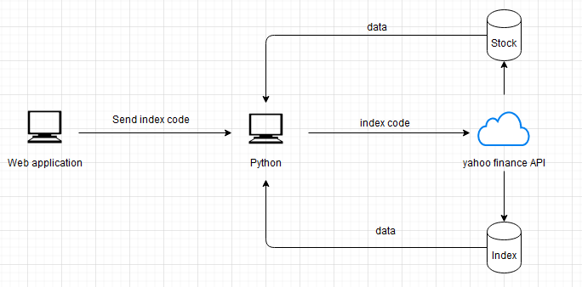

User provide a index code for python to get the fractional stock of the index for database

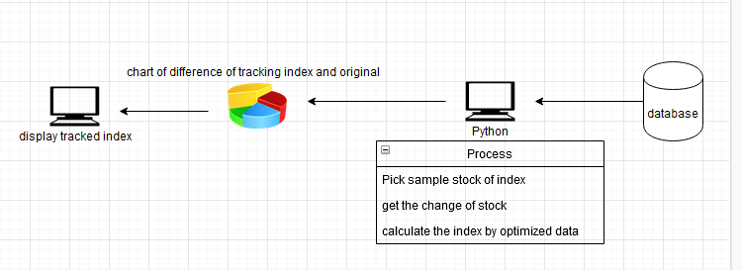

When the database sends back the data of the fractional stock, python picks some of the stock data to track the index, the change of stock also get for calculating the index change by different formula. Then it will generate a chart to show the difference between the original index and tracked index.

**Index prediction**

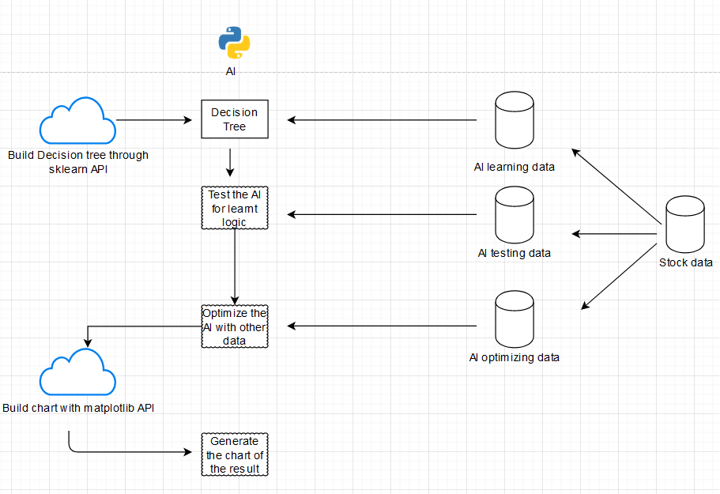

Before starting the AI prediction, it has to set the target of the AI. Then prepare the data for AI to use. In this situation, we prepare the fractional stock data of the tracked index. After collecting the data, we have to decide which AI model to use in this AI. For using in predicting the stock, we choose the decision tree to be the model, because stock market will have a lot of human factors, decision trees can set the situation for AI to make decisions.

After that, prepare the model answer of the data for feeding to the AI, the model is used for help AI to recognize which decision it makes is correct and which are not. At the same time, the data will separate in 3 parts, the first part of data is used for feeding the AI to learn the logic between the data. The data also includes the technical index to be one part of data to feed the AI. The second part of data is to test the logic of AI learnt from first data correct or not. The third part of data is use for optimize the AI to make it become better and the prediction more accurate. The predicted data will display to user as a chart

### 

### E.Implementation Issues of Prototype

Index tracking had been completed. However, the process needs a long time to calculate. Excluding upgrading the hardware, we have to find some solutions to get less process time.

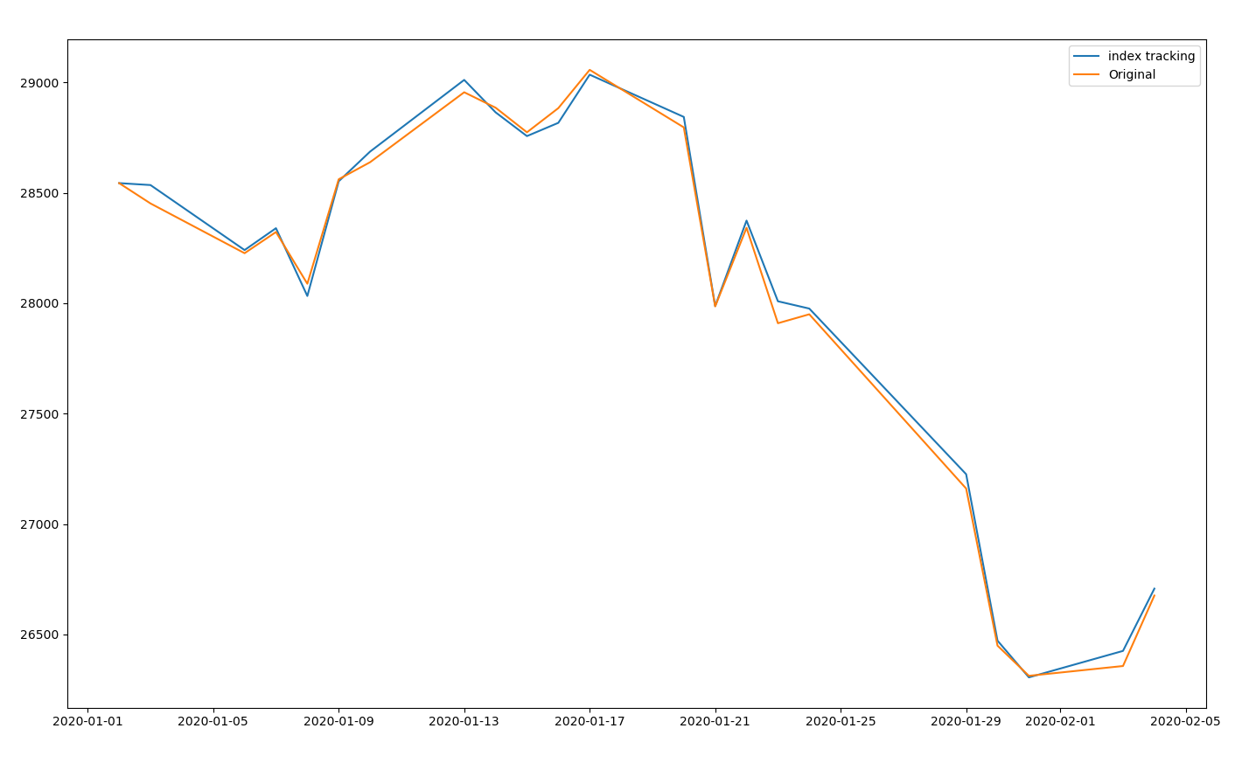

Chart of original index and tracked index

### F.Evaluation Design

We will make two rounds of the testing. In the first round, the student who has a touch in stock will be selected. They can base their knowledge to find out the AI is useful or not and any condition can be added to the decision tree to make the AI predict more accuracy.

For the second round, the student who wants to participate in the stock market will be selected. Their feedback is let us know about the can learn any knowledge from the application to find out anything to be updated.

## References

1. Census & Statistics Department, Hong Kong Special Administrative Region. Hong Kong monthly digest of statistics, Hong Kong monthly digest of statistics (May 2019). Hong Kong.
2. Related Fee of ETF  
   (<https://djinfo.cathaysec.com.tw/school/ET920000.htm>)
3. Stock Portfolio in Python

(<https://programmingforfinance.com/2018/02/tracking-a-portfolio-with-python/>)

1. Yahoo Finance (<https://finance.yahoo.com/>)
2. PHP vs Python: Which Should You Choose in 2019? ERIC BOERSMA MAY 25, 2019 DEVELOPER TIPS, TRICKS & RESOURCES (<https://stackify.com/php-vs-python-which-should-you-choose-in-2019/>)
3. Do You Know The Difference Between Data Analytics And AI Machine Learning? (<https://www.forbes.com/sites/forbesagencycouncil/2018/08/01/do-you-know-the-difference-between-data-analytics-and-ai-machine-learning/#2a24cf565878>)
4. Index tracking, index tracking low cost build

(<https://wizardforcel.gitbooks.io/python-quant-uqer/190.html>)

## Appendix A. Progress Report

### Overview of Project Progress

In the first few months, our project progress is following well to our plan. We have done many tasks within the plan such as building the web page, setting up the database, getting the data from the internet. However, in Jun 2020, we noted that there are some tasks in our plan that don't meet our aim. For example, some calculation of stock is no need to do in this project. We should mainly focus on the index but not on each stock. Since we need to change the plan, our project progress is falling behind from the plan.

.

### Revised Project Plan

|  |  |
| --- | --- |
| Date | Task |
| 05/09/2019 | Identify the project theme |
| 11/09/2019 | Discuss current situation and problems |
| 11/09/2019 | Research about current solutions and technologies |
| 20/09/2019 | Start coding the system |
| 03/10/2019 | First presentation & Review presentation |
| 24/10/2019 | Initial Report Submission |
| 10/2019 | Progress Rate Review |
| 11/2019 | Second presentation |
| 12/2019 | Complete basic function of system |
| 01/2020 | Interim Report Submission |
| 03/2020 | Mock Presentation & Review |
| 05/2020 | Final presentation & Submission of Final Report |

### 

## Appendix B. Team Members' Roles and Responsibility

The following table outlines the roles of every team member in this project.

|  |  |  |
| --- | --- | --- |
| Roles | Member(s) | Remarks |
| Team Coordinator | Fung Wai Yin |  |
| Secretary | Fung Wai Yin |  |
| System Analyst & Designer | Fung Wai Yin | Python |
| Application Layout & UI Designer | Pun Cheuk Kwan | PHP |
| Function Designer & Manager | All members |  |
| Programmer | All members |  |
| Tester and Evaluator | All members |  |
| Database Expert | Yung Chun To Samuel | Apache |
| Cloud Server Expert | Yung Chun To Samuel |  |

The following table outlines the task responsibility of every team member in this project.

|  |  |  |
| --- | --- | --- |
| Tasks | Responsible Member(s) | Target Date |
| Technology Test: Python get stock data | Fung Wai Yin | Oct 2019 |
| Technology Test: Python generate chart | Fung Wai Yin | Oct 2019 |
| Technology Test: Algorithm for lowest difference between original index and virtual index | Fung Wai Yin | Nov 2019 |
| Technology Test: Use AI to calculate the best rate of stock allocation | Fung Wai Yin | Dec 2019 |
| Web Application: Design Layout and UI | Pun Cheuk Kwan | Nov 2019 |
| Web Application: User Account | Pun Cheuk Kwan | Nov 2019 |
| Web Application: Risk assessment | Pun Cheuk Kwan | Dec 2019 |
| Server: Account and User Data Management | Yung Chun To Samuel | Oct 2019 |
| Server: Database Management | Yung Chun To Samuel | Nov 2019 |
| Database Setup and Maintenance | Yung Chun To Samuel | Nov 2019 |
| Cloud Server Setup and Maintenance | Yung Chun To Samuel | Nov 2019 |
| Questionnaire Design | Fung Wai Yin | Jan 2020 |
| User Experience Review | All members | Jan 2020 |

## Appendix C. Team Meeting Minutes

Meeting 1

|  |  |  |
| --- | --- | --- |
| Date: 13/09/2019 | Time: 11:00am | Place: 9/F, Block A, OUHK |
| Attendee:   1. All members | | |
| Discussion:   * The details of the topic of final year project | | |
| Conclusions:   * Topic defined | | |

Meeting 2

|  |  |  |
| --- | --- | --- |
| Date: 20/09/2019 | Time: 11:30am | Place: 9/F, Block A, OUHK |
| Attendee:   1. Fung Wai Yin 2. Pun Cheuk Kwan | | |
| Discussion:   * Research result , facing problem and schedule of the programming | | |
| Conclusions:   * Decide to spend 6 hour per week | | |

Meeting 3

|  |  |  |
| --- | --- | --- |
| Date: 04/10/2019 | Time: 11:00am | Place: 9/F, Block A, OUHK |
| Attendee:   1. All members | | |
| Discussion:   * Show the progress rate of the program | | |
| Conclusions:   * Need to speed up | | |

## Appendix D1. Fung Wai Yin's Interim Report

### A. Information Box

FUNG Wai Yin (11965651)

Fyp_fyp

An Intelligent Index Tracking System

Dr. LEUNG Man Fai

### B. Declaration Statement

I, FUNG Wai Yin (11965651), certify that the work is original and I have utilized guidance of our supervisor

in completing this project, and that the content which is not our own has been attributed and

referenced properly. There should be no copyrighted content without permission to use. There

should be no confidential data.

Signature and Date

### C. Tasks Assigned to the Author and their Status

|  |  |  |  |  |
| --- | --- | --- | --- | --- |
| Tasks | Responsible Member(s) | Target Date | Completion | Remarks |
| Technology Test: Python get stock data | Fung Wai Yin | Oct 2019 | completed |  |
| Technology Test: Python generate chart | Fung Wai Yin | Oct 2019 | completed |  |
| Technology Test: Algorithm for lowest difference between original index and virtual index | Fung Wai Yin | Nov 2019 | completed |  |
| Technology Test: Use AI to calculate the best rate of stock allocation | Fung Wai Yin | Dec 2019 | Not complete | Function canceled( Replace by next function ) |
| Technology Test: Use AI to predict the index result of next day | Fung Wai Yin | Dec 2019 | Not yet complete |  |
| Questionnaire Design | Fung Wai Yin | Jan 2020 | Not yet complete |  |
| User Experience Review | All members | Jan 2020 | Not yet complete |  |

### 

### D. Key Successes and Failures by the Author

Key Successes:

Getting the stock data from and reduce 80% of fractional stock of the index, and the difference between original index and tracked index is low.



Failures:

Running the prediction program will take too long. Also the stock and index data are not complete before trading hour, the prediction program will run after the trading hour finish and calculate the result for the next day to reference.

## Appendix D2. Pun Cheuk Kwan's Interim Report

### A. Information Box

PUN Cheuk Kwan(12213395)

Fyp_fyp

An Intelligent Index Tracking System

Dr. LEUNG Man Fai

### B. Declaration Statement

I, PUN Cheuk Kwan(12213395), certify that the work is original and I have utilized guidance of our supervisor

in completing this project, and that the content which is not our own has been attributed and

referenced properly. There should be no copyrighted content without permission to use. There

should be no confidential data.

Signature and Date

### C. Tasks Assigned to the Author and their Status

|  |  |  |  |  |
| --- | --- | --- | --- | --- |
| Tasks | Responsible Member(s) | Target Date | Completion | Remarks |
| Web Application: Design Layout and UI | Pun Cheuk Kwan | Nov 2019 | Completed |  |
| Web Application: User Account | Pun Cheuk Kwan | Nov 2019 | Completed |  |
| Web Application: Risk assessment | Pun Cheuk Kwan | Dec 2019 | Not Yet Complete | Going to combine with other part |
| User Experience Review | All members | Jan 2020 | Not Yet Complete |  |

### D. Key Successes and Failures by the Author

Key Successes:

Generate main information in the index page( Favourited stock .etc )

Failures:

In the very beginning, we are trying to show all the stock details we collected on the page, but it is too much for a website. It will make the site loading time be too long. So we cut down the number of stock to show and make a search function to replace it.

## Appendix D3. YUNG Chun To Samuel's Interim Report

### A. Information Box

YUNG Chun To Samuel (12108522)

Fyp_fyp

An Intelligent Index Tracking System

Dr. LEUNG Man Fai

### B. Declaration Statement

I, YUNG Chun To Samuel (12108522), certify that the work is original and I have utilized guidance of our supervisor

in completing this project, and that the content which is not our own has been attributed and

referenced properly. There should be no copyrighted content without permission to use. There

should be no confidential data.

Signature and Date

### C. Tasks Assigned to the Author and their Status

|  |  |  |  |  |
| --- | --- | --- | --- | --- |
| Tasks | Responsible Member | Target Date | Completion | Remark |
| Server: Account and User Data Management | Yung Chun To Samuel | Oct 2019 | Incomplete |  |
| Server: Database Management | Yung Chun To Samuel | Nov 2019 | Incomplete | On Progress |
| Database Setup and Maintenance | Yung Chun To Samuel | Nov 2019 | Incomplete | On Progress |
| Cloud Server Setup and Maintenance | Yung Chun To Samuel | Nov 2019 | Incomplete |  |
| User Experience Review | All members | Jan 2020 | Not Yet Complete |  |

### D. Key Successes and Failures by the Author

Key Successes:

Successful on applying knowledge in Database subject and apply in the project

Failures:

Need time to understand the principle of cloud server cause the delay of progress